EXPERIMENT–1
IoE Sensor Data Acquisition and Preprocessing using Python in Google Colab

Aim:
To acquire and analyze IoE sensor data consisting of Temperature, Humidity, Pressure, Heart Rate, and SpO₂ readings using Python in Google Colab
Software required:
- Google Colab
- Python 3
- Pandas
- NumPy
- Matplotlib
- Scikit-learn (for normalization)
- Web Browser (Google Chrome/Microsoft Edge)

Procedure :
Open Google Colab and create a new Python notebook. Import the required Python libraries such as Pandas, NumPy, Matplotlib, and Scikit-learn. Create or load the IoE sensor dataset containing Temperature, Humidity, Pressure, Heart Rate, and SpO₂ values. Display the dataset to verify the collected sensor readings. Check the dataset for missing values and duplicate records and perform preprocessing by handling missing values and removing duplicates if present. Normalize the sensor values to bring all features into a common range. Visualize the processed sensor data using suitable graphs such as line plots and bar charts to understand the sensor behavior. Finally, save the cleaned dataset as a CSV file and observe the generated statistical summary and graphical outputs.

Theory:
The Internet of Everything (IoE) extends the Internet of Things (IoT) by connecting people, processes, data, and smart devices to create intelligent systems. IoE enables sensors to continuously collect and exchange real-time information for monitoring and decision-making. In this experiment, different sensor parameters such as Temperature, Humidity, Pressure, Heart Rate, and SpO₂ are collected and analyzed.
Before sensor data is used for Artificial Intelligence (AI) and Machine Learning (ML), it must be preprocessed to improve its quality. Data preprocessing includes checking and handling missing values, removing duplicate records, normalizing sensor values into a common range, and visualizing the data using graphs. These preprocessing techniques improve data quality and make the dataset suitable for further analysis and predictive modeling.
Algorithm:
Step 1
Start Google Colab.
Step 2
Import required libraries.
Step 3
Load IoE sensor dataset.
Step 4
Display dataset.
Step 5
Check missing values.
Step 6
Fill missing values.
Step 7
Remove duplicate records.
Step 8
Normalize sensor values.
Step 9
Visualize sensor readings.
Step 10
Save cleaned dataset.
Step 11
Stop.
Flowchart;
Start
│
Import Libraries
│
Load Dataset
│
Check Missing Values
│
Fill Missing Values
│
Remove Duplicates
│
Normalize Data
│
Visualize Data
│
Save Dataset
│
End

Python Program (Google Colab);
# Sensor Data Acquisition and Preprocessing using Python

import pandas as pd
import matplotlib.pyplot as plt

# ----------------------------
# Step 1: Create Sensor Dataset
# ----------------------------
sensor_data = {
"Temperature":[28,29,30,31,29],
"Humidity":[65,66,68,69,67],
"Pressure":[1012,1011,1010,1013,1011],
"HeartRate":[78,80,81,79,80],
"SpO2":[98,99,97,98,99]
}
df = pd.DataFrame(sensor_data)
# Save dataset
df.to_csv("sensor_data.csv", index=False)
# ----------------------------
# Step 2: Read Dataset
# ----------------------------
df = pd.read_csv("sensor_data.csv")
print("Original Dataset")
print(df)
# ----------------------------
# Step 3: Data Preprocessing
# ----------------------------
# Check missing values
print("\nMissing Values:")
print(df.isnull().sum())

# Remove duplicate rows
df = df.drop_duplicates()

# Display cleaned dataset
print("\nCleaned Dataset")
print(df)
# Statistical Summary
print("\nStatistical Summary")
print(df.describe())
# ----------------------------
# Step 4: Data Visualization
# ----------------------------
# Temperature
plt.figure(figsize=(6,4))
plt.plot(df["Temperature"], marker='o')
plt.title("Temperature")
plt.xlabel("Sample")
plt.ylabel("Temperature (°C)")
plt.grid()
plt.show()

# Humidity
plt.figure(figsize=(6,4))
plt.plot(df["Humidity"], marker='o')
plt.title("Humidity")
plt.xlabel("Sample")
plt.ylabel("Humidity (%)")
plt.grid()
plt.show()

# Heart Rate
plt.figure(figsize=(6,4))
plt.bar(df.index, df["HeartRate"])
plt.title("Heart Rate")
plt.xlabel("Sample")
plt.ylabel("Heart Rate (BPM)")
plt.show()

# SpO2
plt.figure(figsize=(6,4))
plt.bar(df.index, df["SpO2"])
plt.title("SpO2")
plt.xlabel("Sample")
plt.ylabel("SpO2 (%)")
plt.show()

# Pressure
plt.figure(figsize=(6,4))
plt.plot(df["Pressure"], marker='o')
plt.title("Pressure")
plt.xlabel("Sample")
plt.ylabel("Pressure (hPa)")
plt.grid()
plt.show()

print("\nExperiment Completed Successfully!")
Sample Dataset :
Temperature Humidity Pressure HeartRate SpO2
28 65 1012 78 98
29 66 1011 80 99
30 68 1010 81 97
31 69 1013 79 98
29 67 1011 80 99a

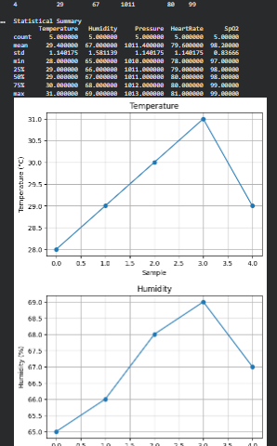

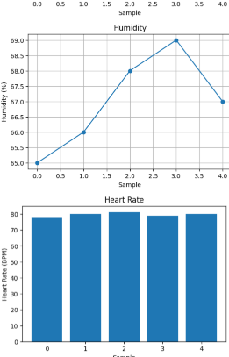
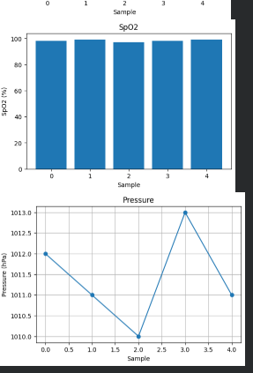

Result:
The IoE sensor data consisting of Temperature, Humidity, Pressure, Heart Rate, and SpO₂ readings was successfully acquired and analyzed using Python in Google Colab.

